

| Project Title | REsearch INfrastructures FOR Citizens in Europe |
| --- | --- |
| Project Acronym | REINFORCE |
| Grant Agreement No. | 872859 |
| Start Date of Project | 01.12.2019 |
| Duration of Project | 36 Months |
| Project Website | www.reinforceeu.eu |
| **D0.0 User Manual: Web Version** | |
| Work Package | **WP00 SonoUno: Sonification Software for astronomical data files presented in table format.** |
| Lead Author (Org) | **Bioing. Johanna Casado** |
| Contributing Author(s) (Org) | **Dr. Beatriz García**  **Dr. Wanda Diaz Merced**  **Bioing. Aldana Palma**  **Bioing. Julieta Carricondo Robino**  **Mg. Ing. Gonzalo A. De la Vega** |
| Due Date | **DD.MM.YYY** |
| Date | **DD.MM.YYY** |
| Version | **V1.0** |

| Dissemination Level | |
| --- | --- |
| X | PU: Public |
|  | PP: Restricted to other programme participants (including the Commission) |
|  | RE: Restricted to a group specified by the consortium (including the Commission) |
|  | CO: Confidential, only for members of the consortium (including the Commission) |

## Versioning and contribution history

| **Version** | **Date** | **Author** | **Notes** |
| --- | --- | --- | --- |
| 0.1 | DD.MM.YYY |  | Table of Contents (TOC) |
| 0.2 | DD.MM.YYY |  | Additional TOC sections |
| 0.3 | DD.MM.YYY |  | Contents for Executive Summary, section 1 and 1.1 |
| 0.4 | DD.MM.YYY |  | Contents for section 2 and 2.2 |
| 0.5 | DD.MM.YYY |  | Contents for sections 3, 4, 4.1-6 |
| 0.6 | DD.MM.YYY |  | Contents for section 5 |
| 0.7 | DD.MM.YYY |  |  |
| 1.0 | DD.MM.YYY |  |  |

### Deliverable Abstract

Lorem ipsum dolor sit amet, consectetur adipiscing elit, sed do eiusmod tempor incididunt ut labore et dolore magna aliqua. Ut enim ad minim veniam, quis nostrud exercitation ullamco laboris nisi ut aliquip ex ea commodo consequat. Duis aute irure dolor in reprehenderit in voluptate velit esse cillum dolore eu fugiat nulla pariatur. Excepteur sint occaecat cupidatat non proident, sunt in culpa qui officia deserunt mollit anim id est laborum

### Disclaimer

This document contains information which is proprietary to the REINFORCE Consortium. Neither this document nor the information contained herein shall be used, duplicated or communicated by any means to a third party, in whole or parts, except with the prior consent of the REINFORCE Consortium.

**Table of Contents**

**Versioning and contribution history** **2**

**Deliverable Abstract** **2**

**Disclaimer** **2**

**List of Images** **6**

**List of Tables** **8**

**TERMINOLOGY** **9**

**1. Software description** **10**

**2. Opening the software** **10**

**2.1 QUICK START Guide** **11**

**2.2 Home page** **12**

**2.3 Testing sonoUno web** **14**

**2.4. Things to keep in mind** **15**

**3.0. Opening a file** **15**

**3.1. Opening a Data file** **15**

**3.2. Opening a WAV file** **17**

**3.3. Opening a markers saved file** **19**

**3.4 Mark and Delete all marks button** **20**

**4. Save files** **21**

**5. Exit the sonoUno** **26**

**6. Functionalities** **26**

**6.2 Tempo selection** **27**

**6.3. Play and Pause button** **27**

**6.4. Stop button** **28**

**6.5 Mark point button** **28**

**6.6 Delete last mark button** **29**

**7. Plot and Sound Configurations** **29**

**7.1 Sound configuration** **29**

**7.2. Plot configurations** **31**

**7.2.1. Styles of the data plot** **32**

**7.2.2 Modifying the titles.** **34**

**8. Mathematical Functions** **35**

**8.1 Peak finder** **35**

**8.2 Logarithmic** **36**

**8.3 Quadratic** **36**

**8.4 Smooth** **37**

**9. Shortcut keys-Comments** **37**

## 

## List of Images

Image 1 The image shows Firefox browser and the web landing page of sonoUno 11

Image 2 The image shows Firefox browser and the Quickstart Guide of sonoUno 11

Imagen 3. sonoUno home page. Plot area and menu. 12

Imagen 4. sonoUno home page. Plot area functionalities and Abscissa and Tempo sliders. Bellow, Math Functions bar and bellow that bar, Sound and Plot configuration buttons 13

Imagen 5. sonoUno home page. Sound functionalities and configurations 13

Imagen 6. sonoUno home page. Plot functionalities and configurations 14

Image 7. sonoUnoweb Sample Data Menu 14

Image 8 Shows the items on the menu File and the focus of the keyboard is on the Open item. 16

Image 9 Pop-up window of the File explorer, shown after selecting the item. 16

Image 10. The sonoUno framework with the graph of the imported data, in this case a GW glitch. 17

Image 11 Shows the items on the menu File and the focus of the keyboard is on the Open item. 18

Image 12 Pop-up window of the File explorer, shown after selecting the item. 18

Image 13. The sonoUno framework with the graph of the imported data from the wav file. 18

Image 14 Shows the items on the menu File. 19

Image 15 Pop-up window of the File explorer, shown after selecting the item. 19

Image 16. The sonoUno framework with the graph of the imported data from the wav file. 20

Image 17 Displays the sonoUno interface with an opened data file, in the plot there is one vertical black line (position of the playing coordinate) and several blue circles marking points of interest on the graph. 21

Image 18 Displays the sonoUno interface with an opened data file. At the top Menu, the Output button displays the Save Sound, Save Markers , Save Plot possibilities. 22

Image 19 Shows the file menu opened in the navigation bar and the Save Sound option selected 22

Image 20 Shows the pop up panel that opens after pressing save sound for a Mac. If no pop-up is opened, you may have checked the auto download option on your browser and your file should be in your Downloads folder. 23

Image 21 Shows the Save Markers option focused on the file menu. 23

Image 22 Pop-up window of the computer file system saving the markers csv file (Mac OS) 24

Image 23 The interface is shown before and after clicking the “save markers” button. The play bar is kept in place but markers are erased after saving them to a csv file (Ubuntu OS) 24

Image 24 Data saved from sonoUno web 25

Image 25 A view of the file explorer and both, markers and audio files opened. 25

Image 26 A view of the saved “Markers.csv” file 25

Image 27 Shows the slider, while being selected is possible to move it left and right with your keyboard arrows 26

Image 28 As you can see the percentage of the “Abscissa Position Slider” corresponds to the position of the black line on the plot. 27

Image 29 The tempo slider is on the bottom right of the image. 27

Image 30 The play button is found on the bottom left of the image, under the graph, being the first button 28

Image 31 The stop button is placed next to the Play button. 28

Image 32 The mark point button is found under the graph, next to the stop button. 28

Image 33 The delete last mark button is found on the bottom right of the graph section. It’s the fourth button from left to right. 29

Image 34 Below Abscissa, Tempo and Math sliders are user modifiable configurations for Sound and Plot. 29

Image 35 A slider allows to modify the frequency 30

Image 36 A slider allows to modify the volume of the sound and the sound type 30

Image 37 Advanced Sound Configuration 31

Image 38 Shows the basic plot configuration section 31

Image 39 The style section of the plot configuration counts with three combo boxes that allows users to select from a list of different options to modify the way the graph looks. 32

Image 40 The line style element is a drop-down list with four different styles.In the image the dash-dot line option is selected. 32

Image 41 The marker style element is a drop-down list, where there are different options. In the image the diamond marker style is selected. 33

Image 42 The color style element is a drop-down list, where there are seven options. In the image the orange color style is selected. In addition, the dotted line style and circle marker have been chosen. 34

Image 43 Plot and axes names 34

Image 44. New color and Plot and axes names 34

Image 45 .Predefined mathematical functions 35

Image 46.Modal window with the peak finder settings 36

## 

## List of Tables

Table 1 11

## TERMINOLOGY

| **Terminology/Acronym** | **Description** |
| --- | --- |
| CNRS | Centre National De La Recherche Scientifique |
| CSA | Coordination and Support Action |
| DoA | Description of Action |
| EA | Ellinogermanik i Agogi Scholi Panagea |
| EC | European Commission |
| EGO | European Gravitational Observatory |
| EU | European Union |
| GA | Grant Agreement to the project |
| IASA | Institute of Accelerating Systems and Applications |
| KPI | Key Performance Indicator |
| LC | The Lisbon Council For Economic |
| OU | The Open University |
| REA | Research Executive Agency |
| REINFORCE | REsearch Infrastructure FOR Citizens in Europe |
| UOXF | University of Oxford |
| WP | Work Package |
| ZSI | Zentrum Fur Soziale Innovation |

# 1. Software description

SonoUno is a sonification software for astronomical data presented on a table (txt or csv files). The software is being developed based on the study of other software (Sonification Sandbox, MathTrax and xSonify) and standards of accessibility like the ISO 9241-171:2008 (Guidance on software accessibility) and the Web Accessibility Initiative – Accessible Rich Internet Applications (WAI-ARIA) guidelines. In order to develop the first approach of a graphical user interface, we perform a theoretical framework based on bibliography of user cases, focused on blind and visually impa people.

The development framework is Angular which promotes modularity, in order to do collaborative work. Being this version of SonoUno web based, is accessible from nearly any platform; the development team worked with this aim in mind. The main goal of SonoUno is to allow the user to open data files (txt or csv extension), show the plot and sonify the data. At the moment, the sonification is performed by variation of pitch and the sonification settings allow to change the volume and the timbre.

Additionally, SonoUno allows users to select a specific range of data on the ‘x’ axis, mark and save points of interest in the data, apply predefined mathematical functions (for example, logarithm and square) and manipulate the data arrays with an Octave interface. In the settings section, the user can configure the plot and some features of the sound.

Finally, the software allows the user to save the plot, a text file with the points marked on the data and a csv file with the plotted data.

# 2. Opening the software

Being a web based application accessing to sonoUno it’s as easy as to type the url on your preferred browser:

<http://190.15.198.99:8083/>

This link opens the landing page for the web version of sonoUno

Angular’s support extends to the latest Edge, Firefox, Chrome and Safari versions, so it’s advised to update your browser. (Image 1). If after entering the url you don’t get the sonoUno’s homepage first check:

1. Check that you have typed the correct url.
2. Check your network connection and access to the internet.

If after that you still can’t establish a connection send a message to the development team via email:

sonounoteam@gmail.com

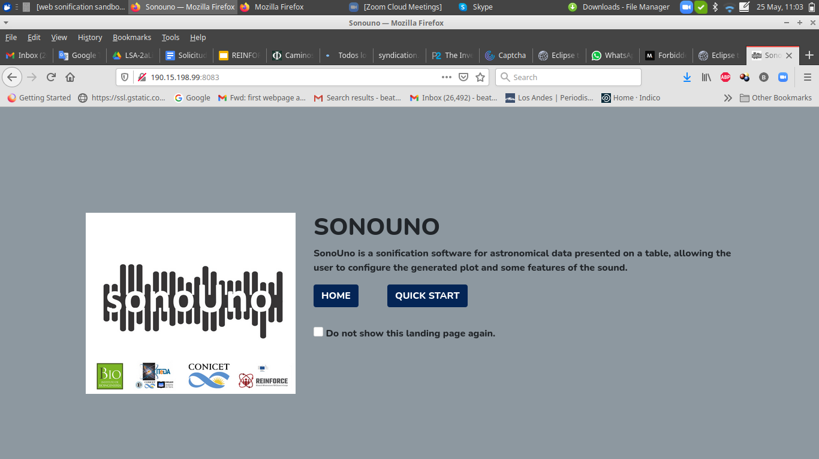

#### Image 1 The image shows Firefox browser and the web landing page of sonoUno

At the landing page it is possible to select between HOME and QUICK START and also decide if not to show this page again.

# 2.1 QUICK START Guide

The recommendation is for the new users to go first to the QUICK START (Figure 2), where a short explanation of each section of the web interface (on the screen) and functionalities setting by default are detailed.

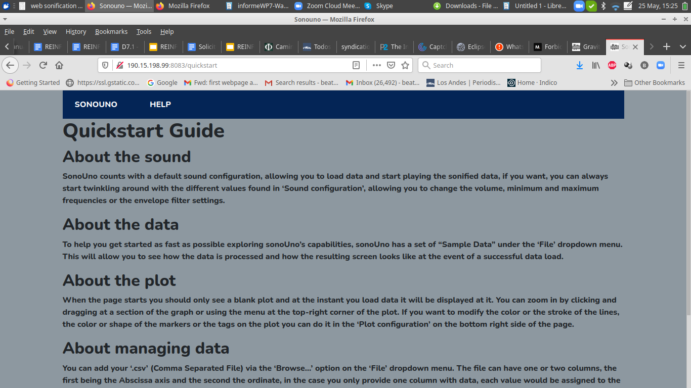

#### Image 2 The image shows Firefox browser and the Quickstart Guide of sonoUno

# 2.2 Home page

The home page of sonoUno greets you with four distinct sections:

1. The navigation bar with the access to the File functionalities; Input/Output functions, Sample data and the access to the Help and the Quickstart guides. This design was based on a user case study (Image 3)
2. The graph has four buttons to control “Play/Pause”, “Stop”, “Mark Point” and “Delete Mark” and two sliders to control the abscissa position and the tempo (Image 4).
3. Below the sliders, a MathFunctions bar permits selecting between simple mathematical functions to apply to the data (Image 4)
4. The sound configuration section has the tools to modify the way audio is processed, if you press on this button you will see all the Sound configuration options (Image 5).
5. The plot configuration section allows you to modify the way the data is displayed in the graph, if you press on this button you will see all the Plot configuration options (Image 6).

Every section will be explained in detail in further chapters of this Help Guide.

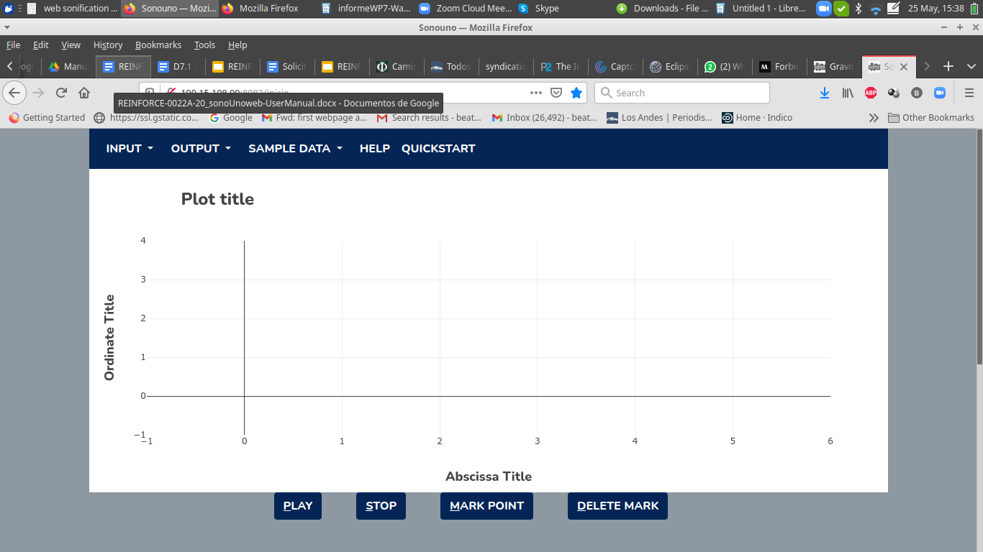

#### Imagen 3. sonoUno home page. Plot area and menu.

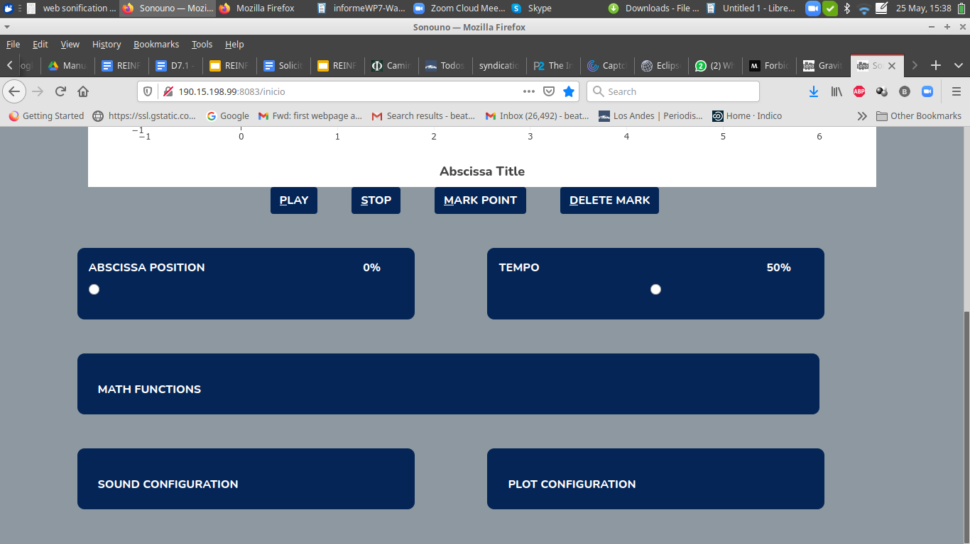

#### Imagen 4. sonoUno home page. Plot area functionalities and Abscissa and Tempo sliders. Bellow, Math Functions bar and bellow that bar, Sound and Plot configuration buttons

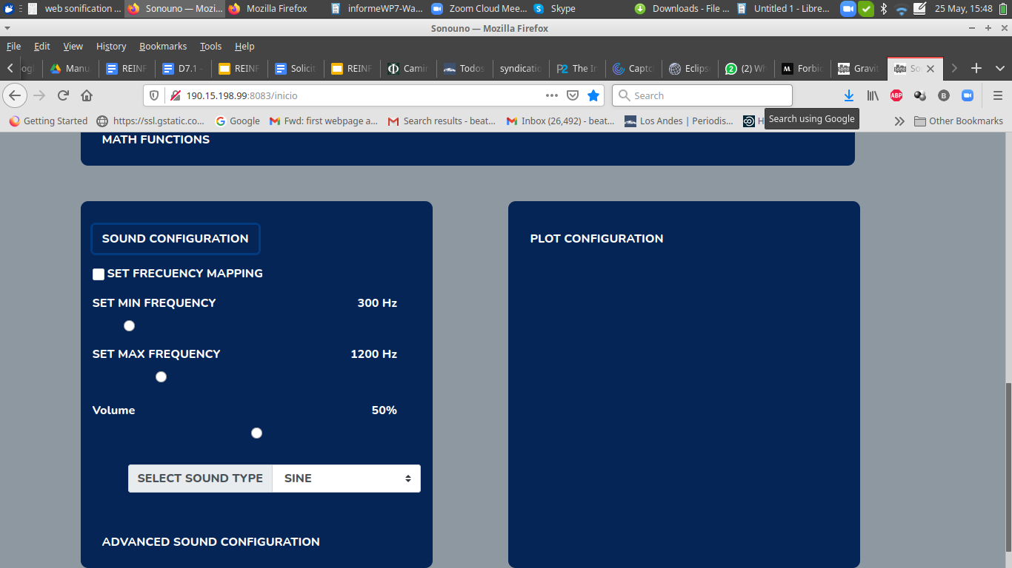

#### Imagen 5. sonoUno home page. Sound functionalities and configurations

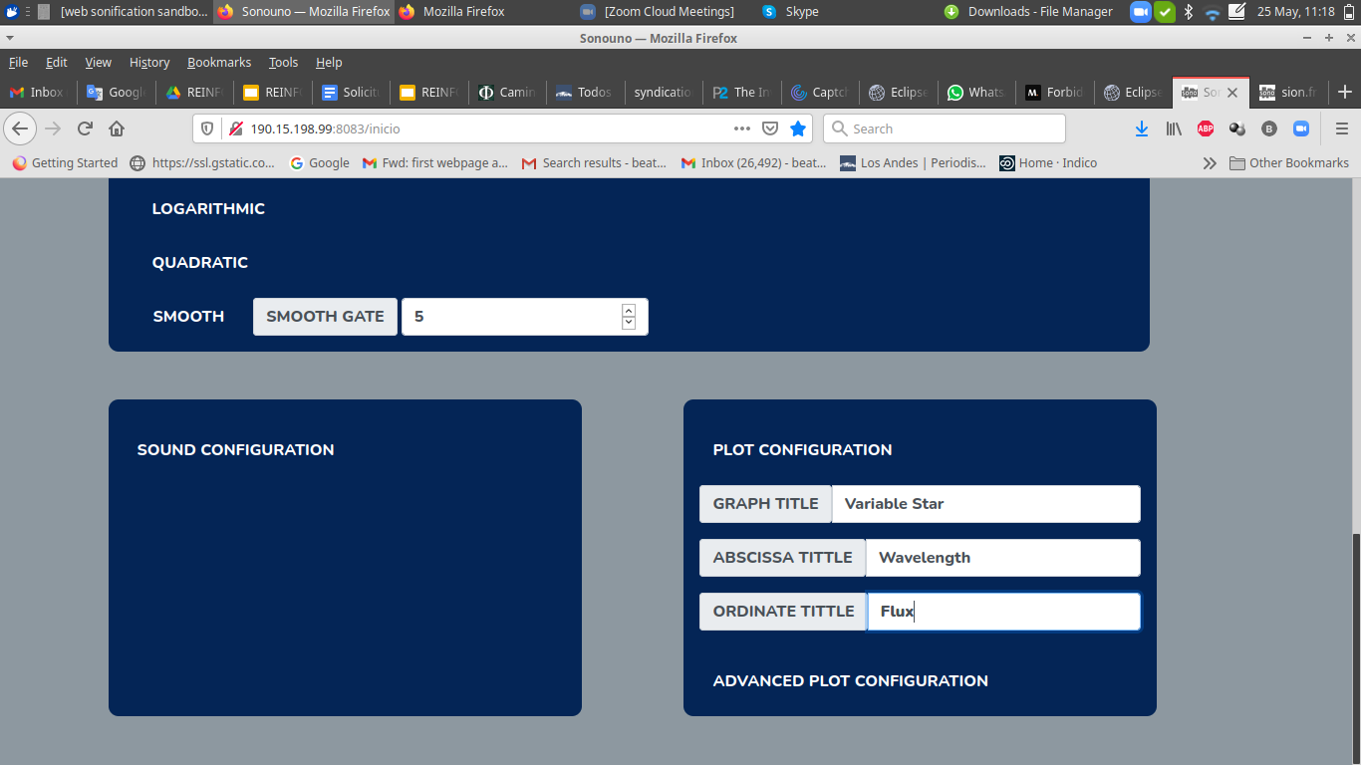

#### Imagen 6. sonoUno home page. Plot functionalities and configurations

# 2.3 Testing sonoUno web

You can start testing the SonoUno functionalities with the sample data that's provided under the dropdown menu “Sample Data”. Just select any of the options under this menu to get the data (Image 7) automatically loaded on your graph area and the audio be ready to play.

In order to listen to the graph just press the button “Play” under the graph. You should see an orange bar moving from left to right indicating the progress on the data being played and hear the pitch variations matching the data.

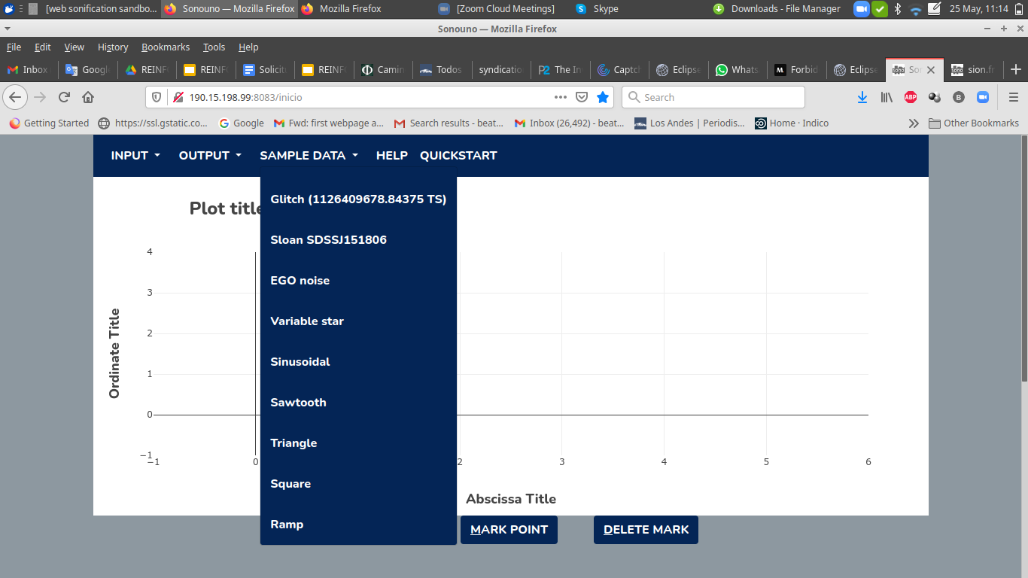

#### Image 7. sonoUnoweb Sample Data Menu

If you can see the black bar moving but still no sound comes out from your headphones or speakers:

1. Check your speakers or headphones connection to your PC.
2. Check your sound configuration: volume level and mute.
3. Check if your browser has blocked the sound reproduction and that the tab is not muted.

 If the problems continue or you have another problem, please inform this to the developer team.

# 2.4. Things to keep in mind

* Some widgets, like warnings or confirmation buttons may be in your browser configured language. Otherwise, the software language is always English. In the future the team is looking forward to unifying the languages.
* In the files to import the first column must have continuous values, it is used as a coordinate dependent axis.
* All screenshots and images shown are for illustration purposes only, the real image can change a little depending on the web browser.

# 3.0. Opening a file

You can open files for three different reasons, you can open a csv with data to be displayed and played by sonouno, you could add a wav file to get the data from its envelope or you could add markers that you have previously saved for that data set.

# 3.1. Opening a Data file

To open a .csv or .txt file with a new data set, you can use the option "Data CSV” under the Input dropdown menu (Image 8). This action will open a pop-up window with your operating system’s file explorer (Image 9), where you can search and open any data file.

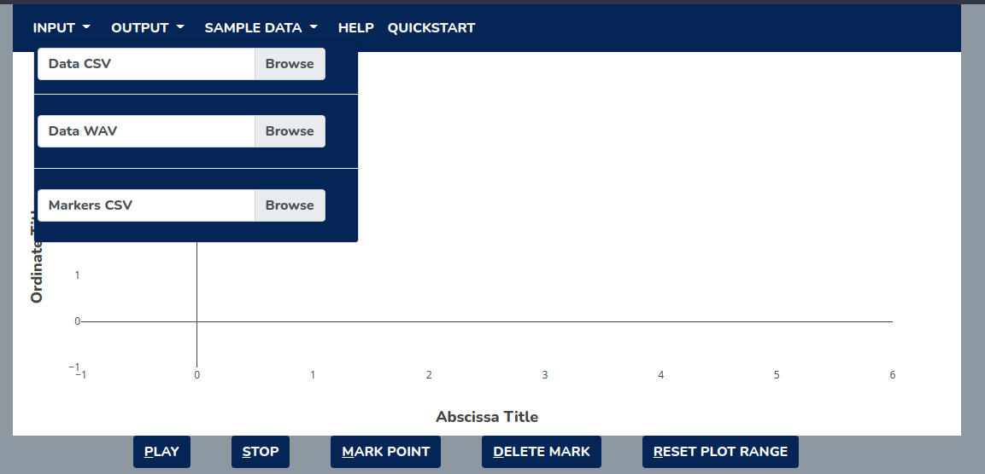

#### Image 8 Shows the items on the menu File and the focus of the keyboard is on the Open item.

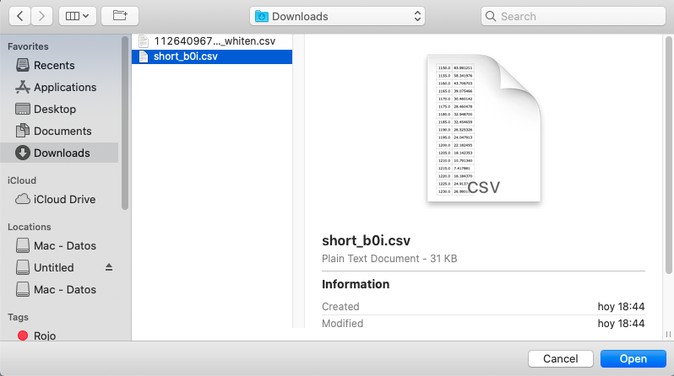

#### Image 9 Pop-up window of the File explorer, shown after selecting the item.

When you have the data file selected, press the button Open or the Enter key. The sonoUno will generate the graph (Image 10) and update the abscissa’s slide bar. Everything is ready, pressing the “Play” button should start the reproduction.

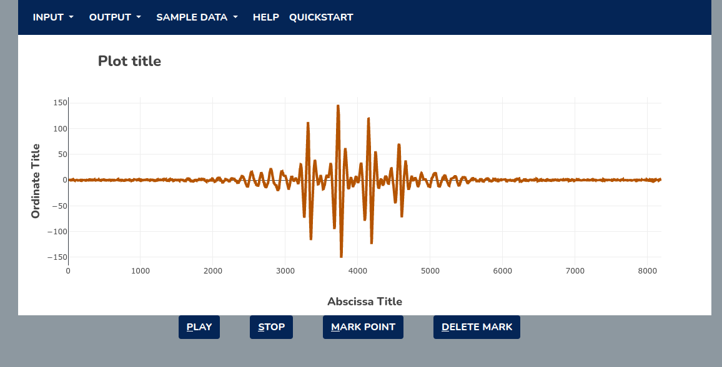

#### Image 10. The sonoUno framework with the graph of the imported data, in this case a GW glitch.

# 3.2. Opening a WAV file

You can open a wav file and get the dataset from its envelope. You can access the functionality under the Input dropdown Menu, and just like in the CSV file, the system file browser will pop up and you'll be able to select the file and load it.

A .wav file has a sampling rate, defined by the amount of values recorded in a second, by now we are calculating the envelope values by the square root of the average of a set amount of values. In the near future we will be adding the possibility of modifying the gate of values for that average, until then it's set to 5.



#### Image 11 Shows the items on the menu File and the focus of the keyboard is on the Open item.

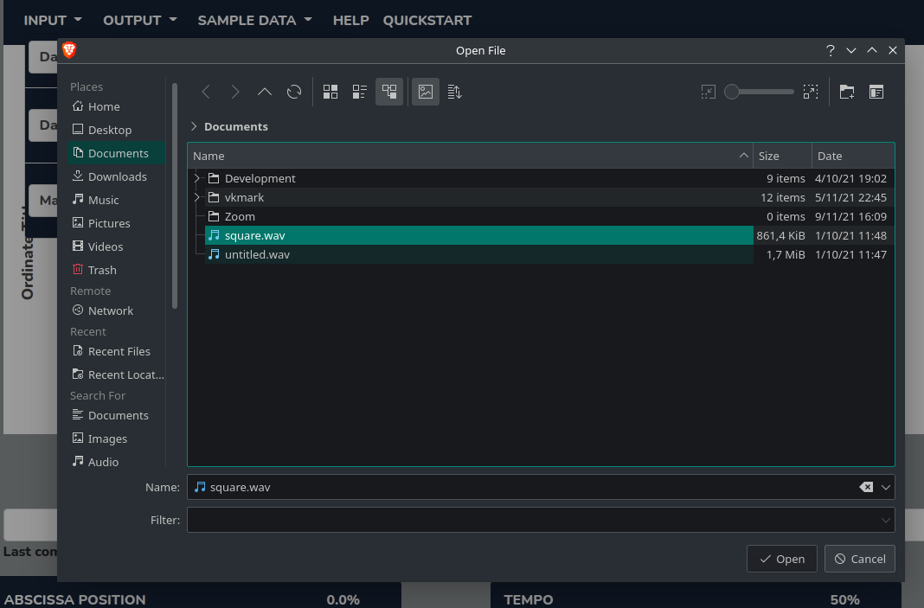

#### Image 12 Pop-up window of the File explorer, shown after selecting the item.

After uploading the wav file, the envelope of the file will be loaded to the graph as a . Everything is ready, pressing the “Play” button should start the reproduction.

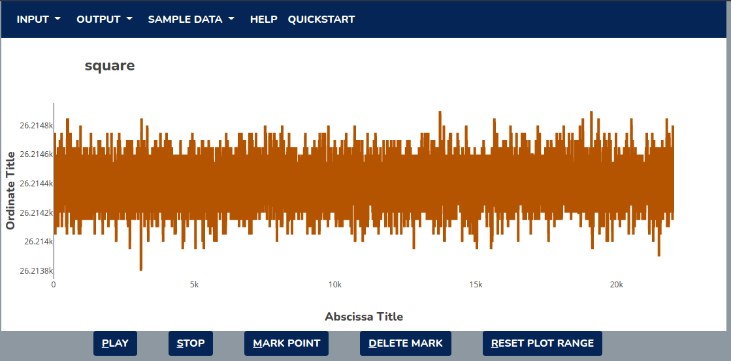

#### Image 13. The sonoUno framework with the graph of the imported data from the wav file.

# 3.3. Opening a markers saved file

You can easily export the list of markers that you add to your given data set via the export markers option, now we will talk about how you can easily import that saved data to apply it again to the data set. You can access the functionality under the Input dropdown Menu, and after clicking in the Markers CSV option you can import the file that you have saved. As it's the web version of SonoUno it will most likely be on your Downloads folder.

#### Image 14 Shows the items on the menu File.

#### Image 15 Pop-up window of the File explorer, shown after selecting the item.

After loading the markers the graph should be updated with the list of markers that you have uploaded, in this case we have only three but you can save and later import as many as you want. It's important to insist that this functionality should be used with the data set where the markers taken, the points of the graph are saved in absolute numbers and not relative to their positions on the plot, loading the markers on another data set with a different range or functions could result in errors and most certainly in failures and unexpected behaviors.

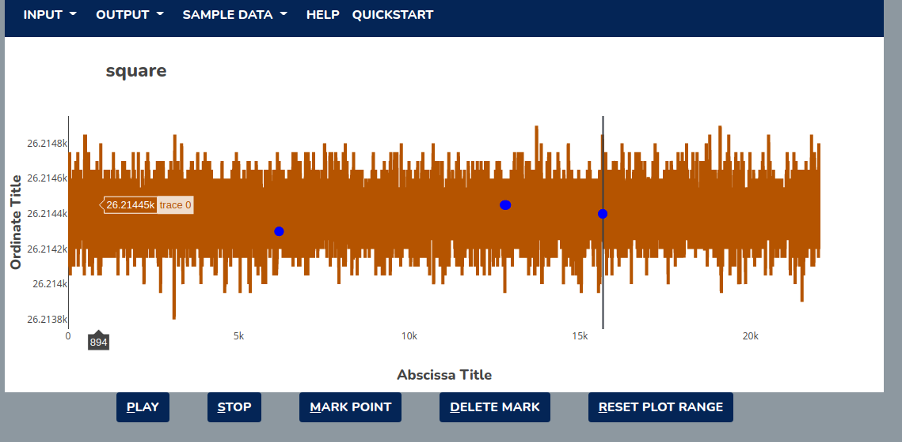

#### Image 16. The sonoUno framework with the graph of the imported data from the wav file.

# 3.4 Mark and Delete all marks button

Before starting with this functionality, we must explain that the sonoUno allows the user to mark points of interest on the data, and store the coordinates on a vector or file. These marks are shown with a diverse amount of user selectable symbols over the plot (Image 17).

I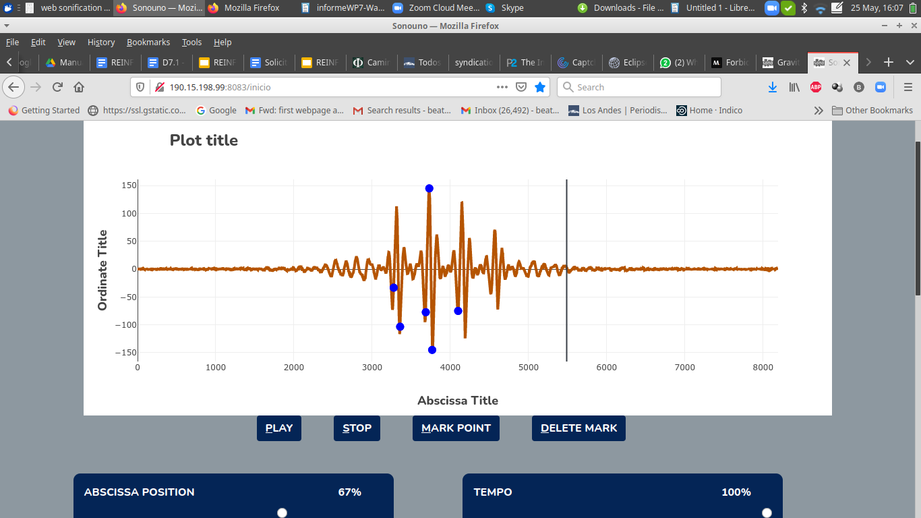

#### Image 17 Displays the sonoUno interface with an opened data file, in the plot there is one vertical black line (position of the playing coordinate) and several blue circles marking points of interest on the graph.

The functionality of the “Delete Mark” button placed under the graph (Image17), is to erase the last added mark point on the data.

# 4. Save files

There are two ways to save files

a) in the dropdown menu, the option “Output” deploys the list of options to save: Sound, Marked Points, Plot (from top to bottom) (Image 18).

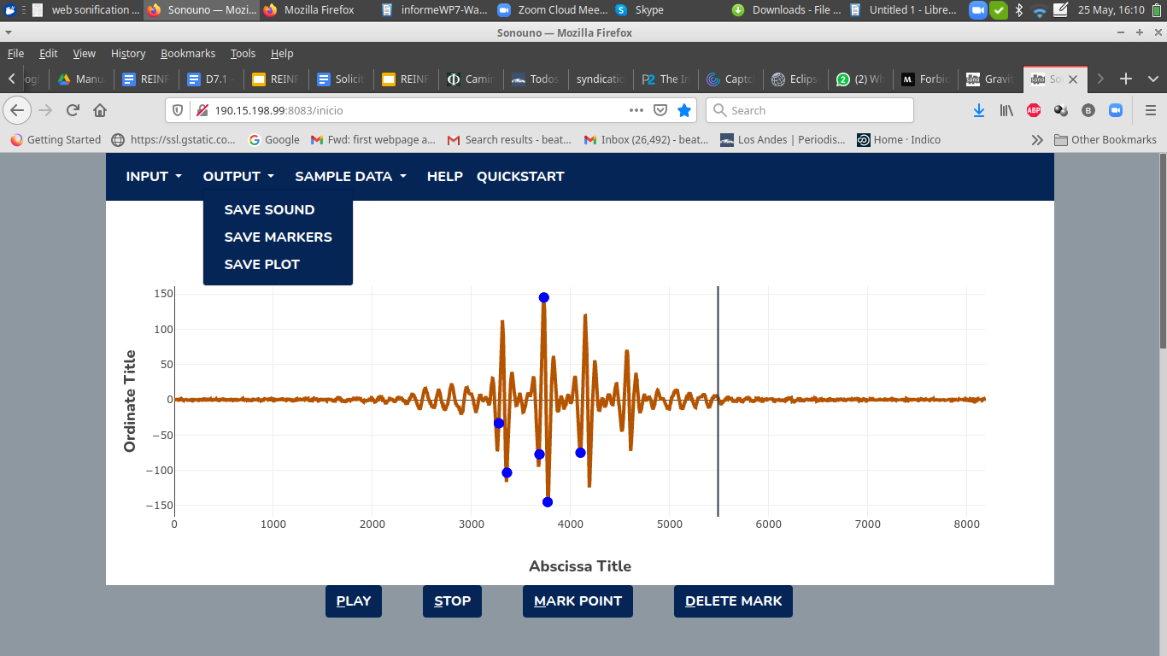

#### Image 18 Displays the sonoUno interface with an opened data file. At the top Menu, the Output button displays the Save Sound, Save Markers , Save Plot possibilities.

the save sound option; and the other is the shortcut Shift+W. Both methods have the same results.

A way the user can store the sound from the data provided to sonoUno is the “Save Sound” feature (Image 19). T In order to save the sound, the user has to press the save sound item on the File menu

The software will process the sound corresponding to the actual data displayed in the plot but with some standard sound configuration and then store it in your computer on a .wav file (image 20).

The process to save the sound depends on the data file and can take some minutes.

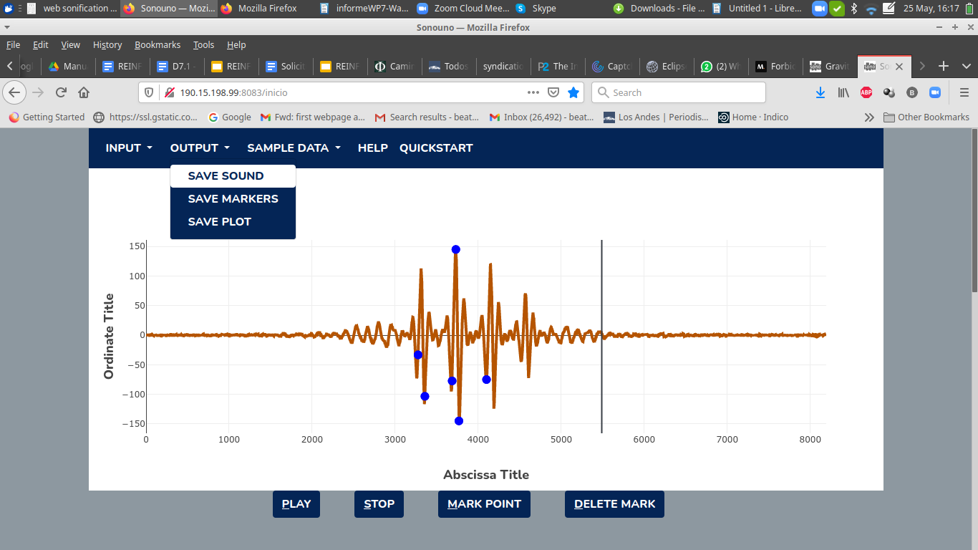

#### Image 19 Shows the file menu opened in the navigation bar and the Save Sound option selected

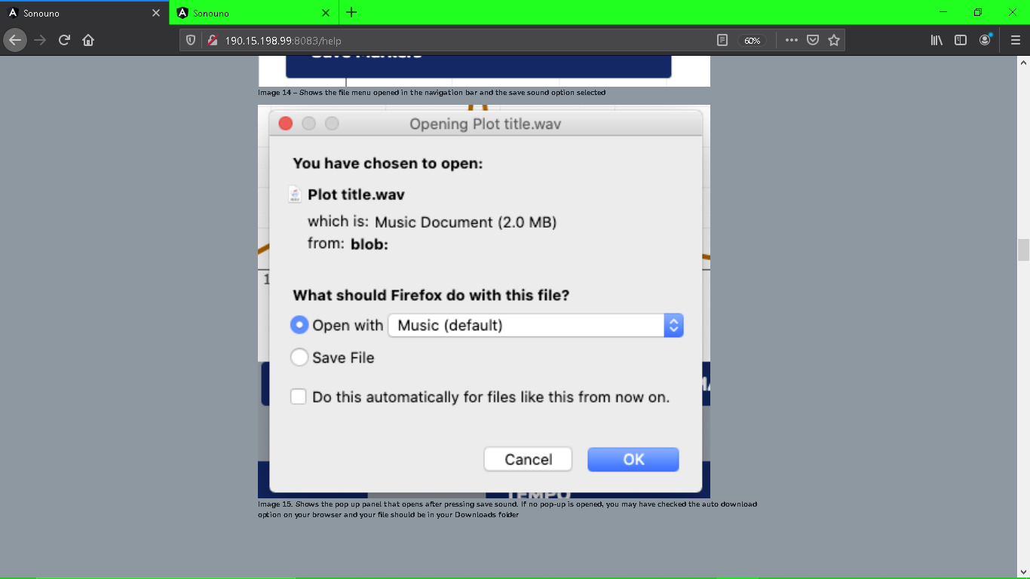

#### Image 20 Shows the pop up panel that opens after pressing save sound for a Mac. If no pop-up is opened, you may have checked the auto download option on your browser and your file should be in your Downloads folder.

Before continuing with the save methods, remember that the software allows to do marks of interest on the data (Image 21), saving the coordinates inside an array, this topic is explained in the corresponding section. We mention it here because in the next lines the save marks method is described.

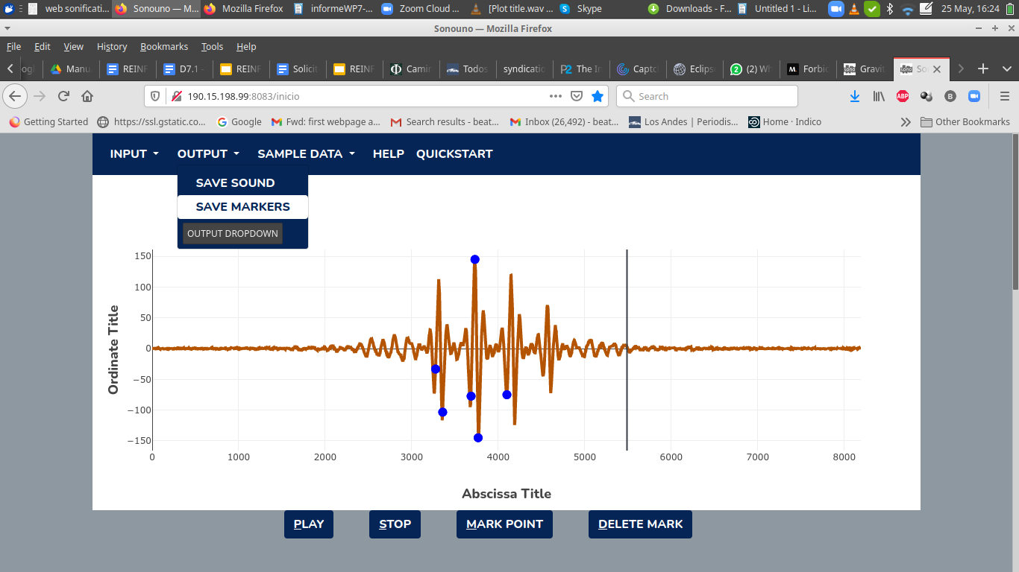

#### Image 21 Shows the Save Markers option focused on the file menu.

In order to save the values of the marks performed on the data array the user has to press the save markers item, placed on the File menu (Image 21).

The save marks option shows a pop-up window of the file system (Image 22) that allows the user to select the directory and the name of the text file. After saving them, the marks are deleted from the sonoUno and the plot (Image 23).

The save markers option shows a similar pop-up window to the “save sound” feature, and then downloads the .csv file. The format of the name is the plot’s title plus “ markers.csv”.

It's important to remember that the array of markers should have at least one marker in order for this to work properly.

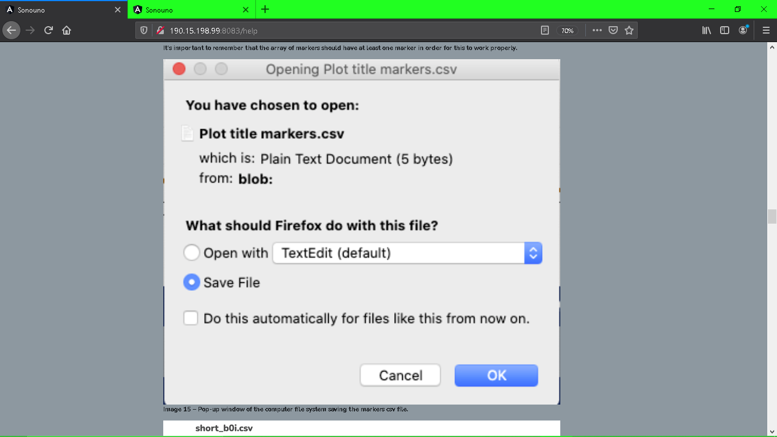

#### Image 22 Pop-up window of the computer file system saving the markers csv file (Mac OS)

 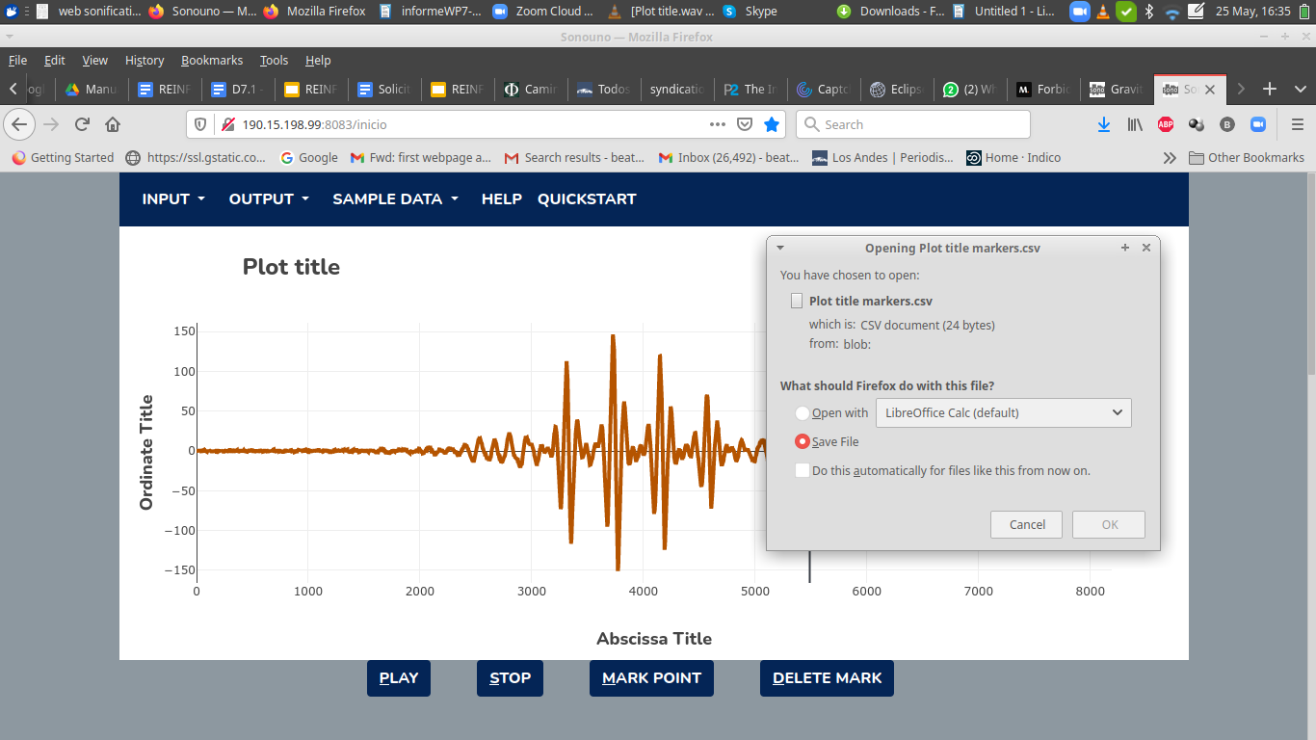

#### Image 23 The interface is shown before and after clicking the “save markers” button. The play bar is kept in place but markers are erased after saving them to a csv file (Ubuntu OS)

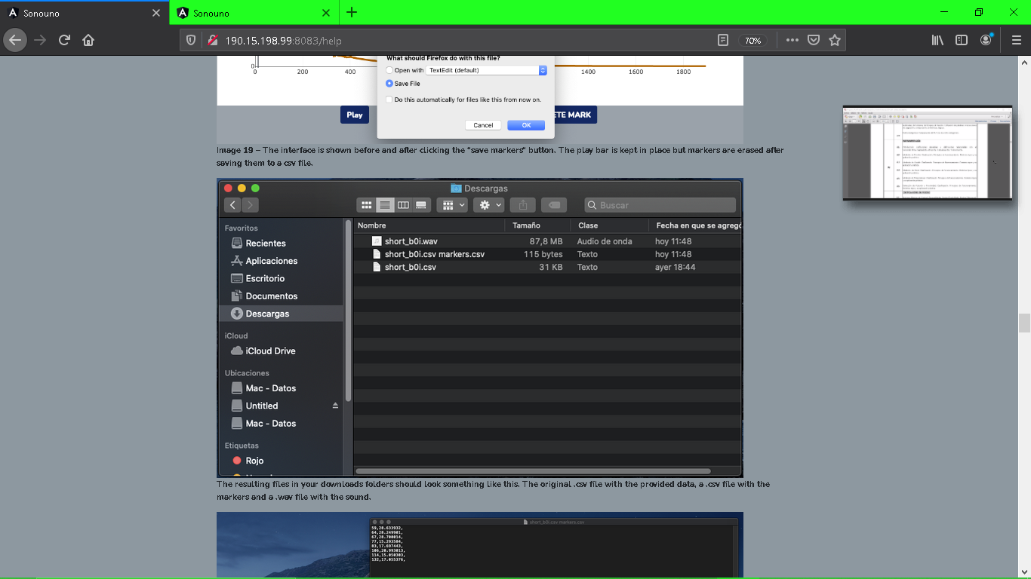

#### Image 24 Data saved from sonoUno web

The resulting files in your downloads folders should look something like in Image 24. The original .csv file with the provided data, a .csv file with the markers and a .wav file with the sound.

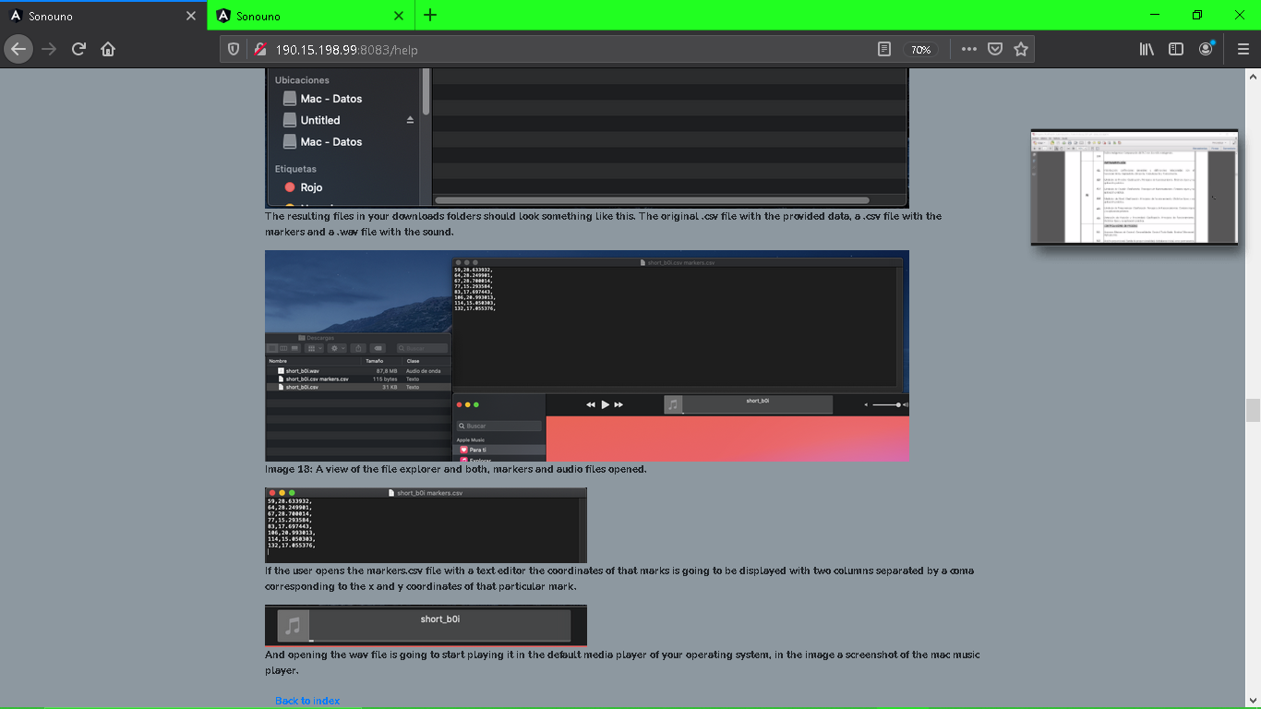

#### Image 25 A view of the file explorer and both, markers and audio files opened.

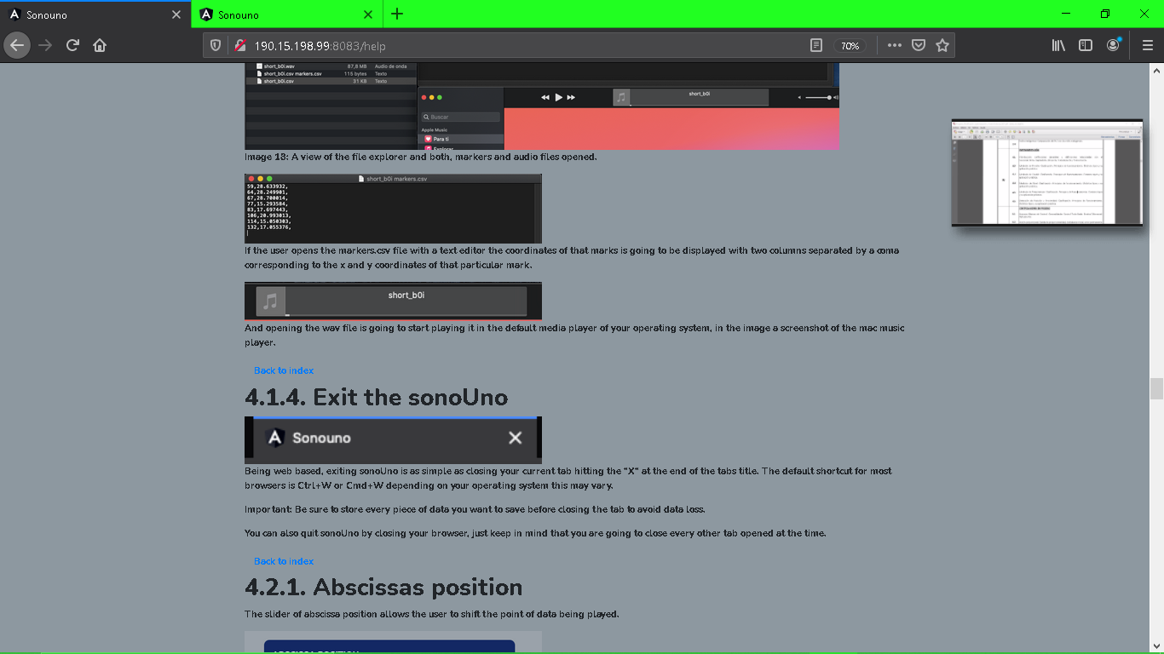

#### Image 26 A view of the saved “Markers.cvs” file

If the user opens the markers.csv file with a text editor the coordinates of that mark are going to be displayed with two columns separated by a comma corresponding to the x and y coordinates of that particular mark (Image 26).



And opening the wav file is going to start playing it in the default media player of your operating system, in the image a screenshot of the mac music player.

# 5. Exit the sonoUno

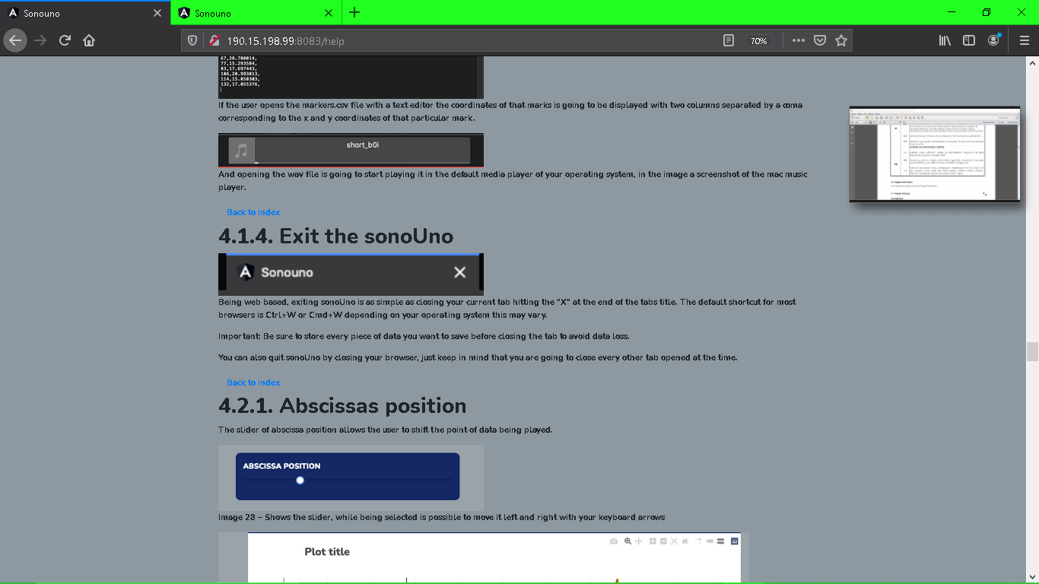

Being web based, exiting sonoUno is as simple as closing your current tab hitting the “X” at the end of the tabs title. The default shortcut for most browsers is Ctrl+W or Cmd+W depending on your operating system, this may vary.

Important: Be sure to store every piece of data you want to save before closing the tab to avoid data loss.

You can also quit sonoUno by closing your browser, just keep in mind that you are going to close every other tab opened at the time.

# 6. Functionalities

6.1 Abscissas position

The slider of abscissa position allows the user to shift the point of data being played (Image 21). The slider shows the posicion (with a number) and also is possible to move it wuth the keyboard arrows if the mouse is on this button .

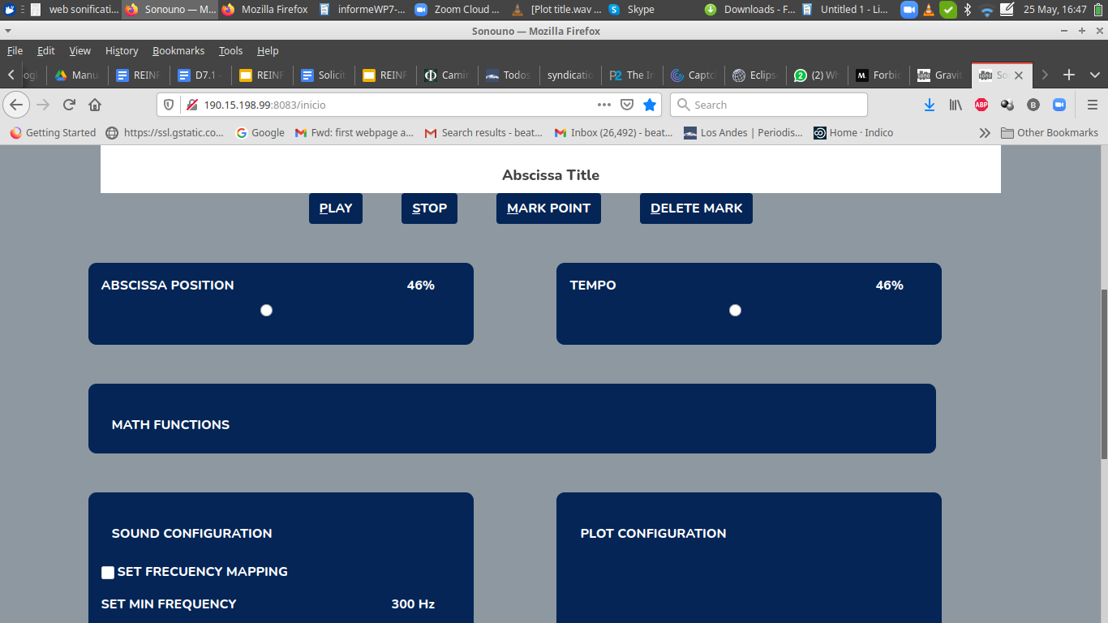

#### Image 27 Shows the slider, while being selected is possible to move it left and right with your keyboard arrows

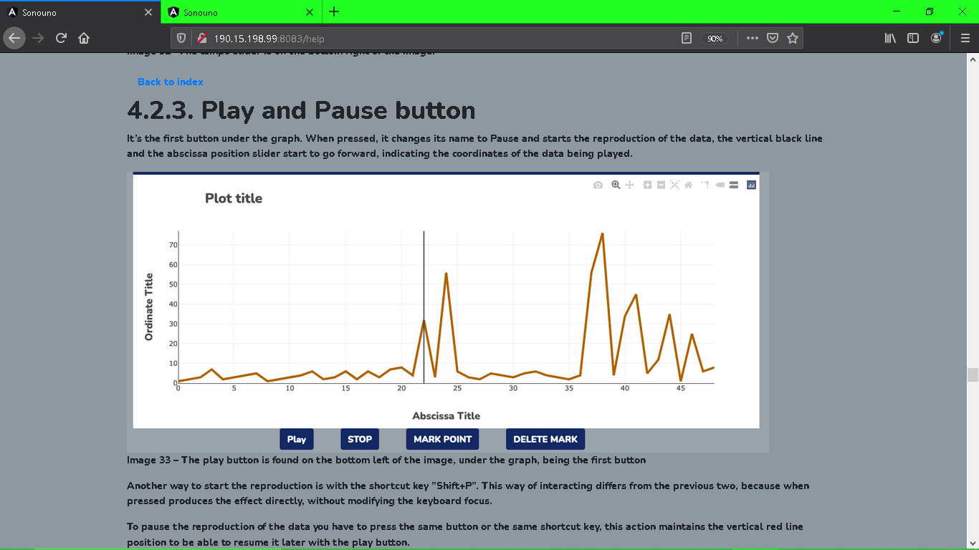

#### Image 28 As you can see the percentage of the “Abscissa Position Slider” corresponds to the position of the black line on the plot.

The abscissa position can be modified before, during and after the reproduction of the data. If the reproduction is in progress, after change the reproduction continues from the new set value.

# 6.2 Tempo selection

This slider controls the duration of each tone. The range goes from 0% to 100%, being 100 the shortest and 0 the longest time.

It’s placed under the plot and to the right of the abscissa slider (Image 30). The operation is analogous to the abscissa position slider.

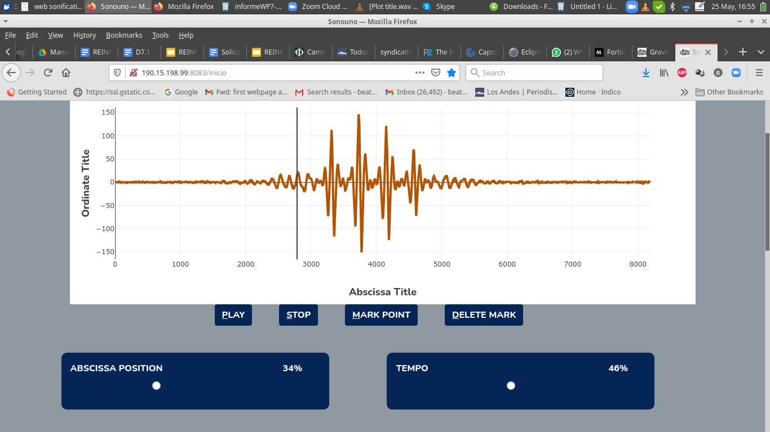

#### Image 29 The tempo slider is on the bottom right of the image.

# 6.3. Play and Pause button

It’s the first button under the graph (Image 30). When pressed, it changes its name to “Pause” and starts the reproduction of the data, the vertical black line and the abscissa position slider start to go forward, indicating the coordinates of the data being played.

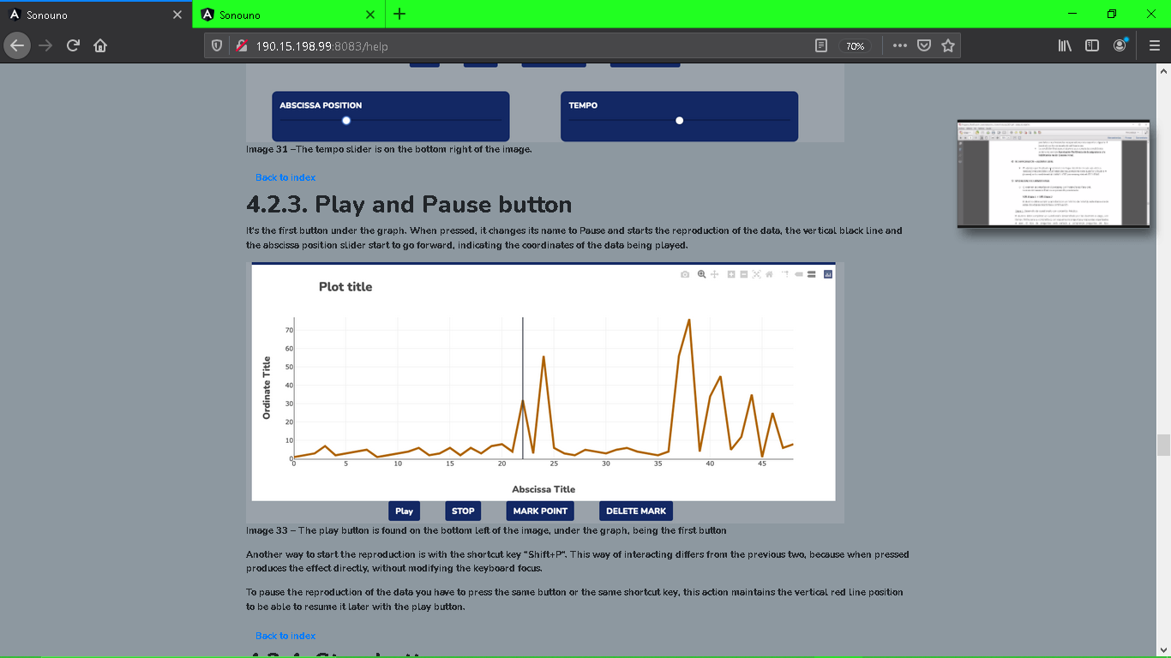

#### Image 30 The play button is found on the bottom left of the image, under the graph, being the first button

Another way to start the reproduction is with the shortcut key ”Shift+P”. This way of interacting differs from the previous two, because when pressed produces the effect directly, without modifying the keyboard focus.

To pause the reproduction of the data you have to press the same button or the same shortcut key, this action maintains the vertical red line position to be able to resume it later with the play button.

# 6.4. Stop button

Its function is to stop the reproduction and restart the process, which means that it sets the abscissa position to zero and deletes the vertical red line from the plot (Image 31). Another way to stop the reproduction is with the shortcut key ‘Shift+S’.

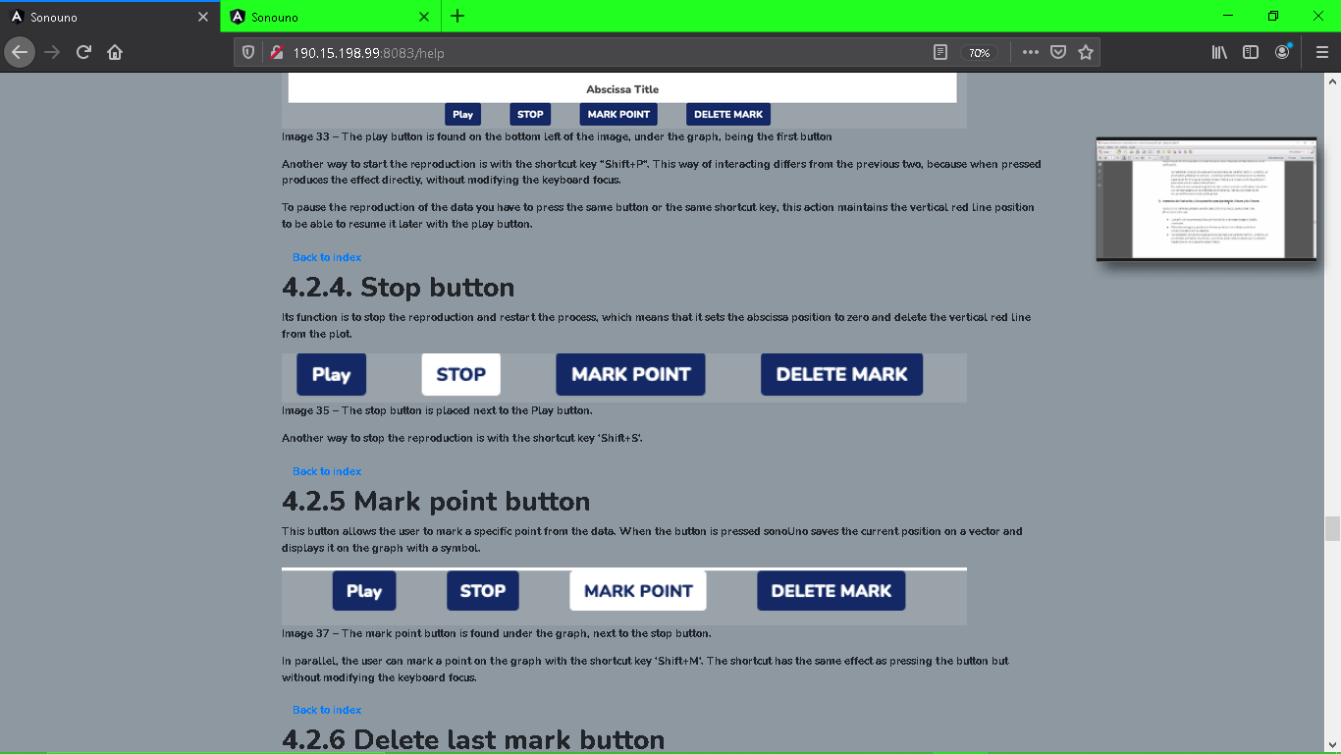

#### Image 31 The stop button is placed next to the Play button.

# 6.5 Mark point button

This button allows the user to mark a specific point from the data. When the button is pressed sonoUno saves the current position on a vector and displays it on the graph with a symbol. (Image 32)

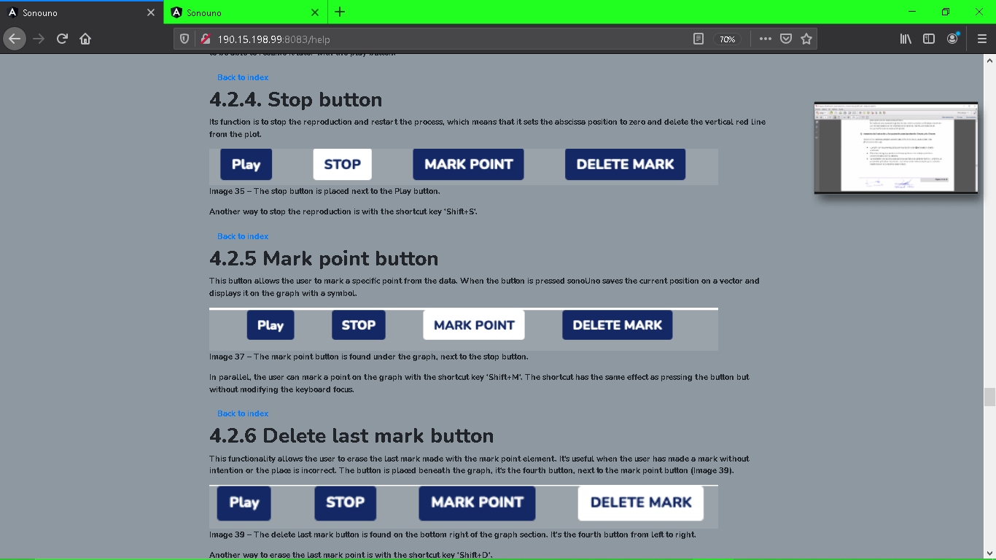

#### Image 32 The mark point button is found under the graph, next to the stop button.

In parallel, the user can mark a point on the graph with the shortcut key ‘Shift+M’. The shortcut has the same effect as pressing the button but without modifying the keyboard focus.

# 6.6 Delete last mark button

This functionality allows the user to erase the last mark made with the mark point element. It’s useful when the user has made a mark without intention or the place is incorrect. The button is placed beneath the graph, it’s the fourth button, next to the mark point button (Image 33).

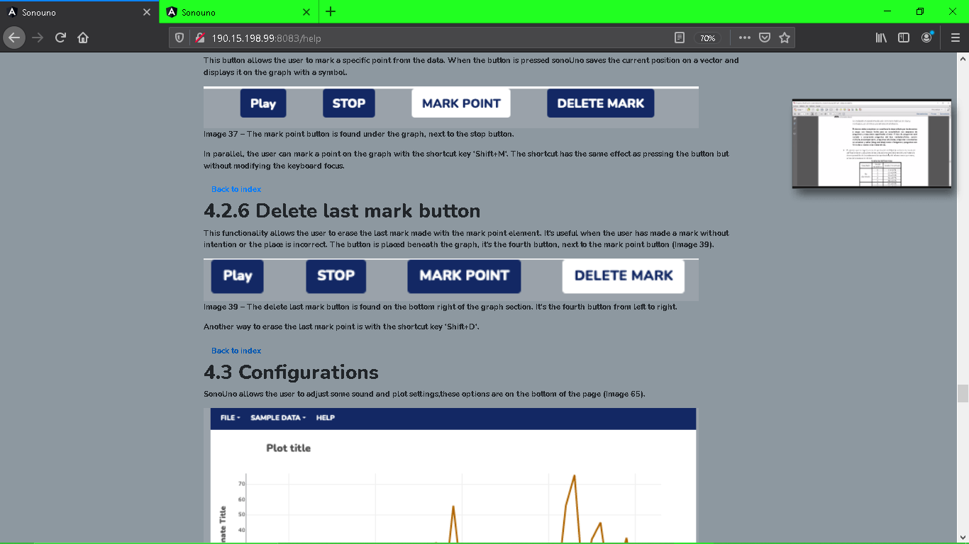

#### Image 33 The delete last mark button is found on the bottom right of the graph section. It’s the fourth button from left to right.

Another way to erase the last mark point is with the shortcut key ‘Shift+D’.

# 7. Plot and Sound Configurations

SonoUno web allows the user to adjust some sound and plot settings,these options are at the bottom of the page (Image 34).



#### Image 34 Below Abscissa, Tempo and Math sliders are user modifiable configurations for Sound and Plot.

# 7.1 Sound configuration

The location of the sound configurations is on the bottom left of the page

The sound configuration can be divided into 3 distincts parts.

1. frequency range and sound types selection (Image 35),
2. volume and buttons to set logarithmic scale and continuous sound (Image 36),
3. advanced functions configuration, which includes the logarithmic scale, discrete or continuous sound and envelop (Image 37)

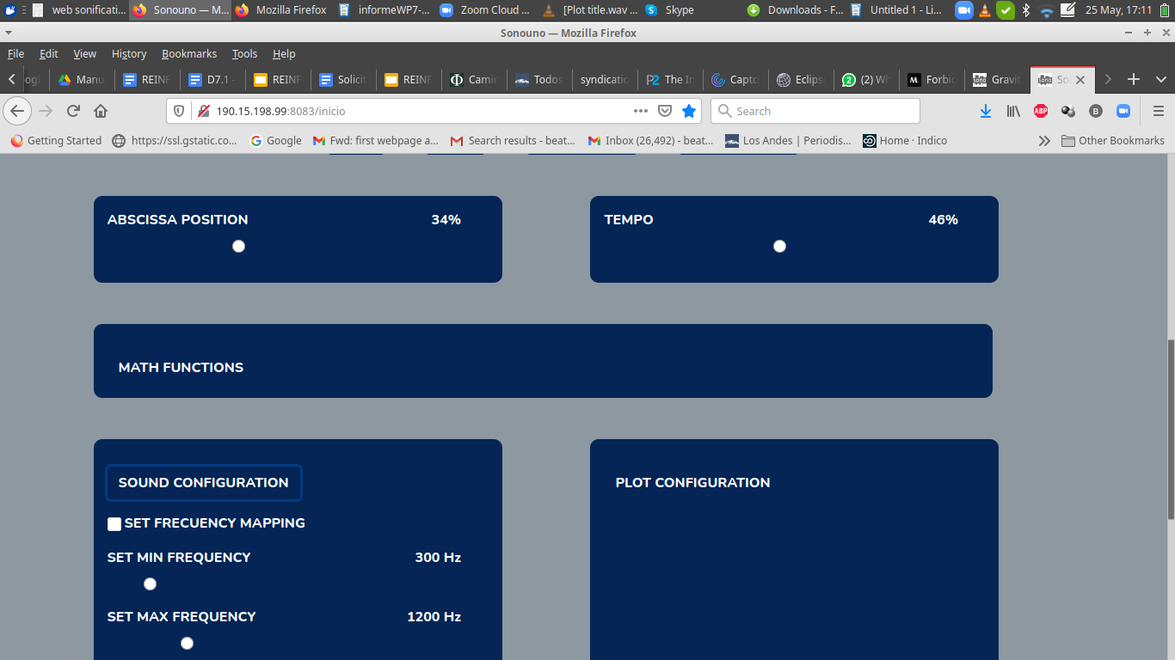

#### Image 35 A slider allows to modify the frequency

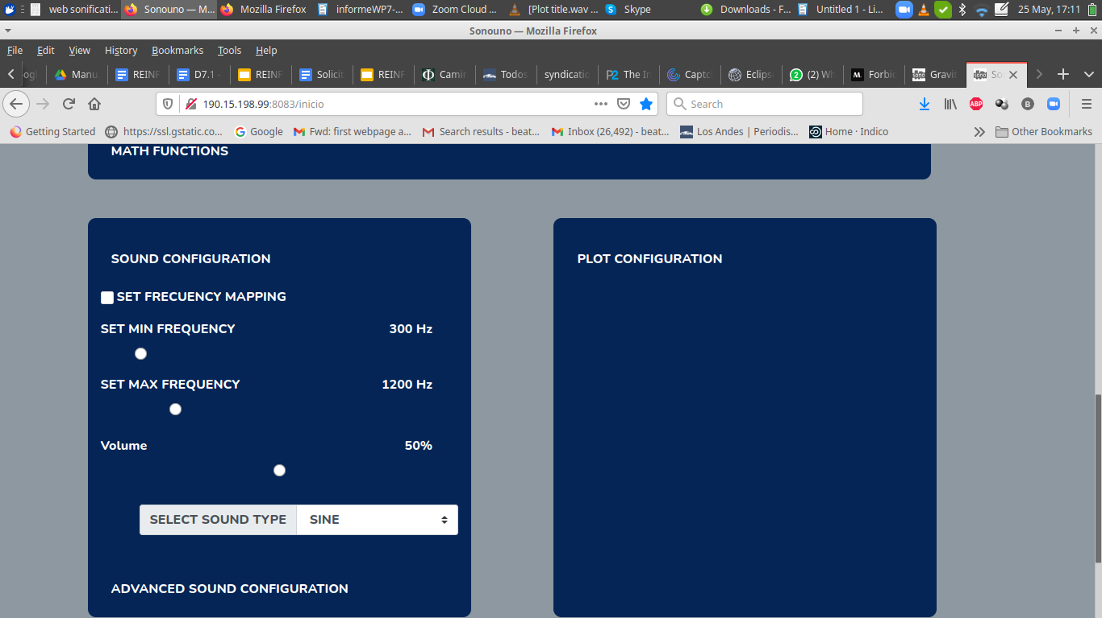

#### Image 36 A slider allows to modify the volume of the sound and the sound type

A checkbox allows for the selection of frequency mapping and the two sliders beneath it modify the minimum and maximum frequency used in the variable mapping.

The next combo box, with a list, allows the user to choose between some sound types to use. These sounds are not intended to sound like real instruments, but rather just loosely recall those instrument’s sounds in order to present the user with some distinguishable options.

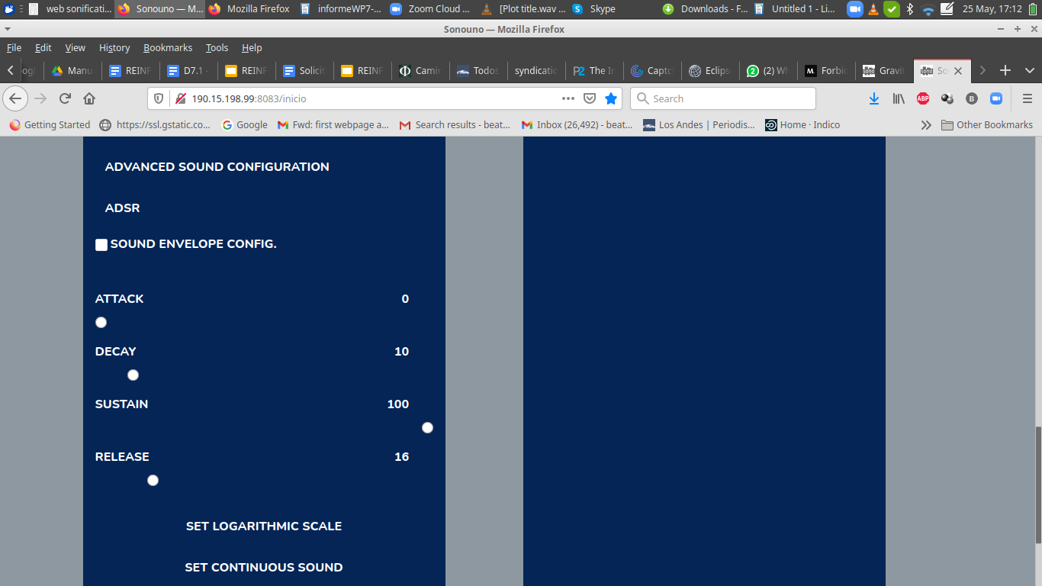

#### Image 37 Advanced Sound Configuration

The Advanced Sound Configurations includes the configuration of envelope filters (Image 37). A checkbox is used to enable and disable the filter. After checking it you can use the attack, decay, sustain and release sliders to modify the resulting sound.

**NOTE:** All the sliders inside the mapping configuration must be enabled and disabled with check boxes, this is to ensure a better navigation with the screen reader and a lower memory overload.

# 7.2. Plot configurations

The plot configurations are located on the bottom right of the page. This tool are divide in

1. basic: title of the plot, name of the axes (Image 38),
2. advanced configurations: line, marker and color styles (Image 39):

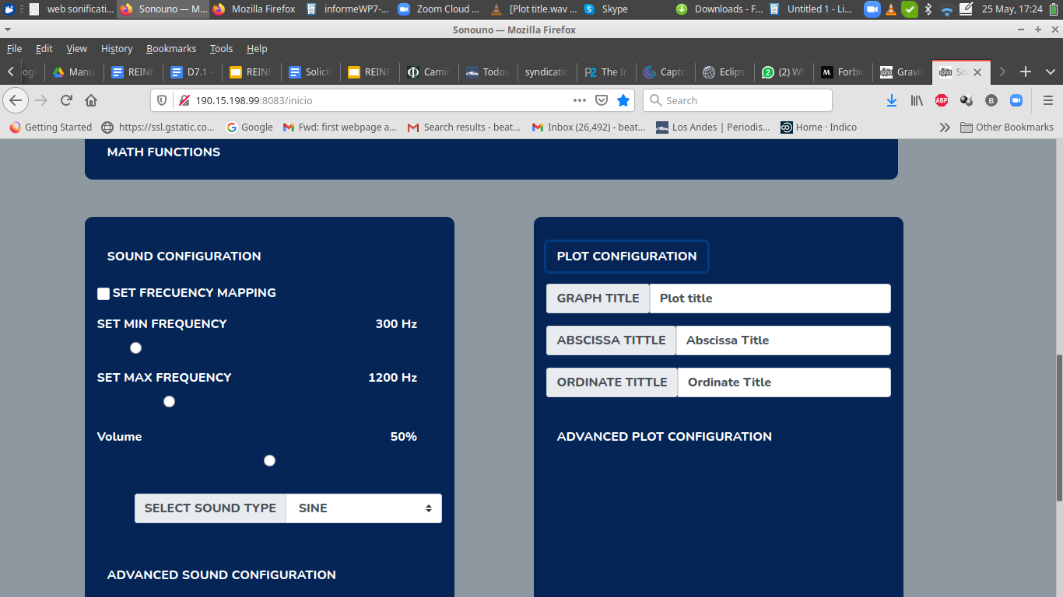

#### Image 38 Shows the basic plot configuration section

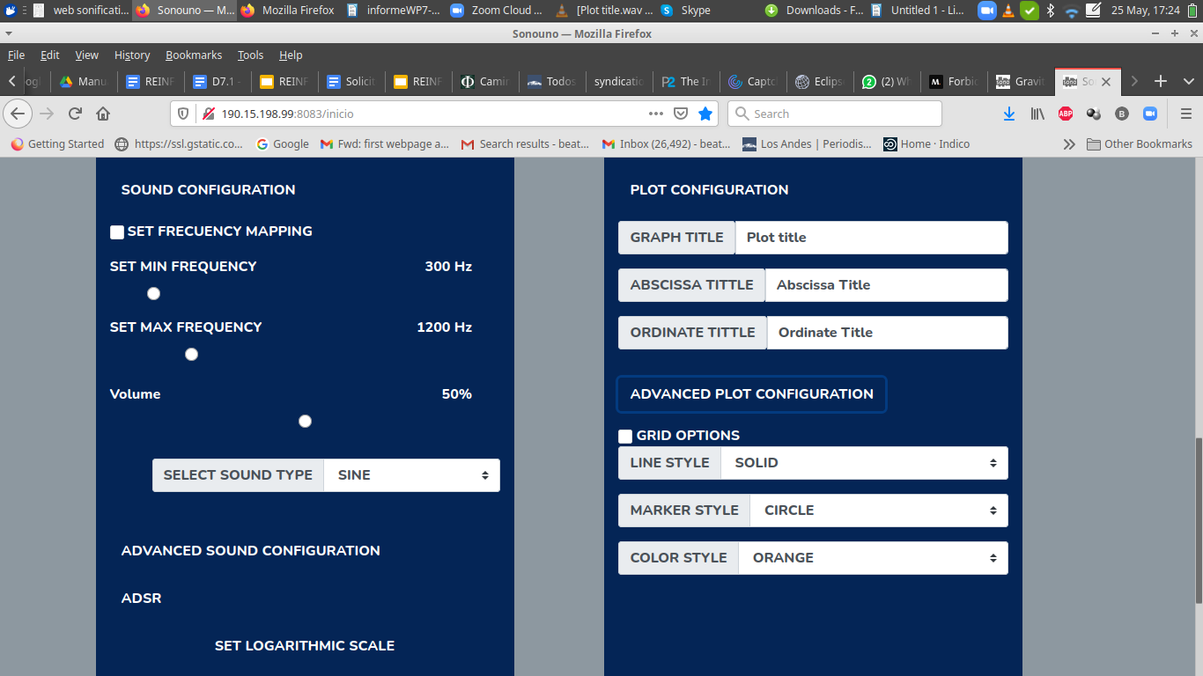

#### Image 39 The style section of the plot configuration counts with three combo boxes that allows users to select from a list of different options to modify the way the graph looks.

If you wish, you can also change the titles of the different parts of the graph. These are simple text boxes with the name that is actually displayed and you can choose to edit the name that is displayed or erase and type a new one. (No need to type enter after modifying it.)

# 7.2.1. Styles of the data plot

On the plot configuration panel, after the line style label, is placed the drop-down list box with five options of style, which are: solid line, dashed line, dash-dot line and dotted line. In the example of the Image 40 the dash-dot line style is shown, with blue color and without markers.

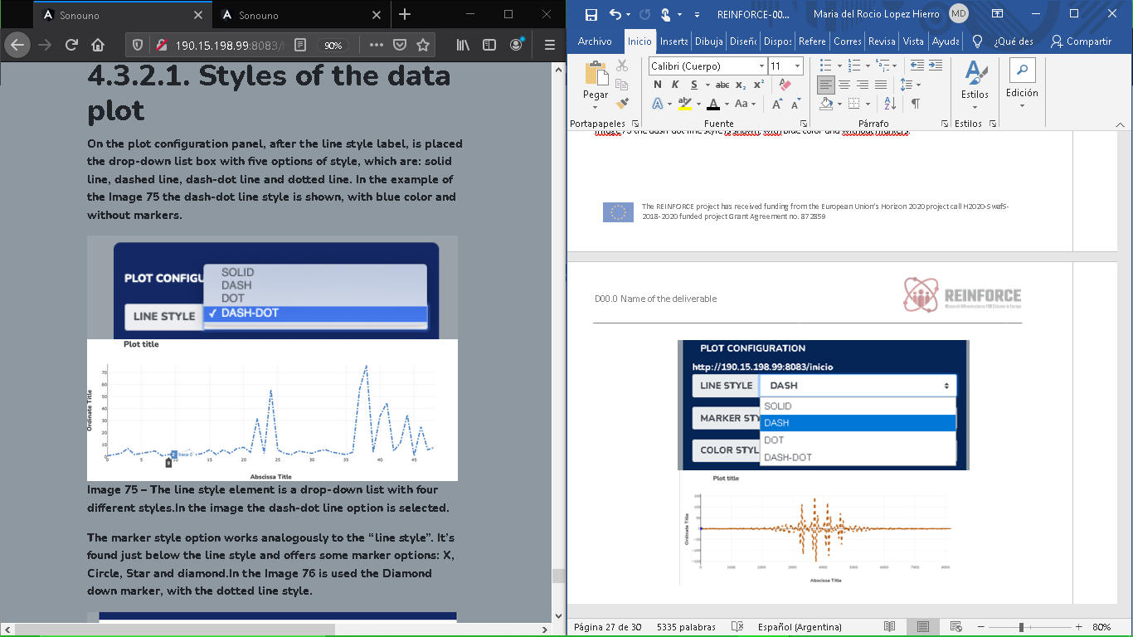

#### Image 40 The line style element is a drop-down list with four different styles.In the image the dash-dot line option is selected.

The marker style option works analogously to the “line style”. It’s found just below the line style and offers some marker options: X, Circle, Star and diamond.In the Image 35 is used the Diamond down marker, with the dotted line style.

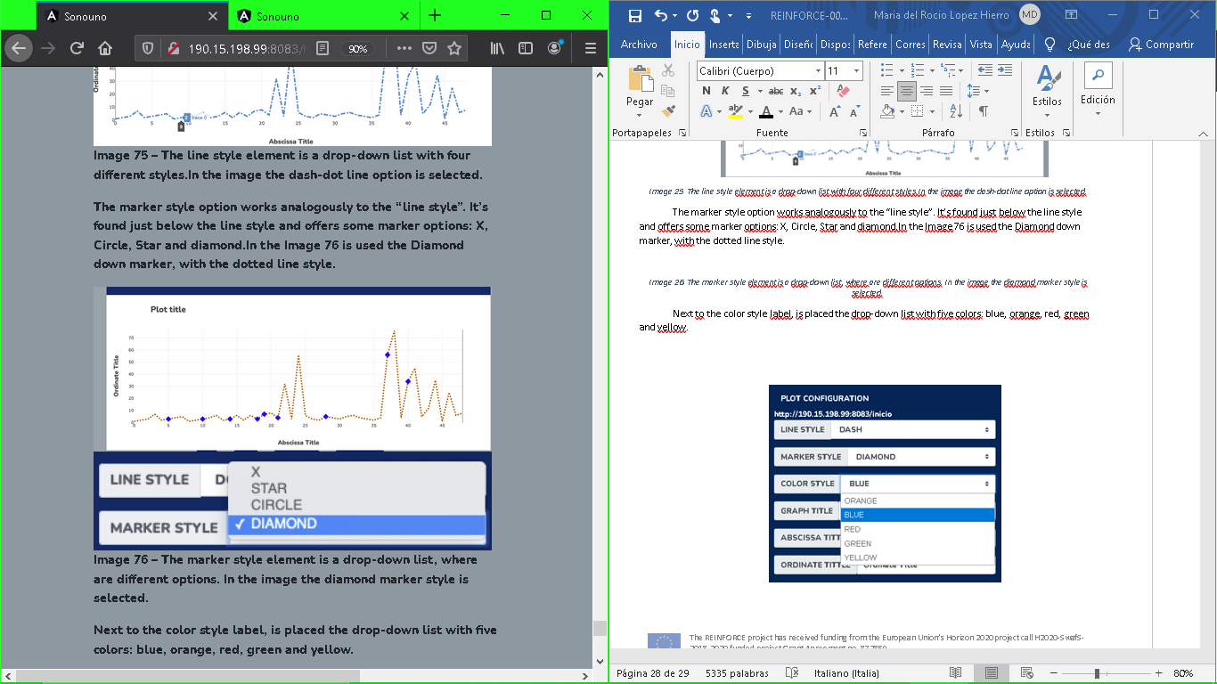

#### Image 41 The marker style element is a drop-down list, where there are different options. In the image the diamond marker style is selected.

Next to the color style label, is placed the drop-down list with five colors: blue, orange, red, green and yellow.

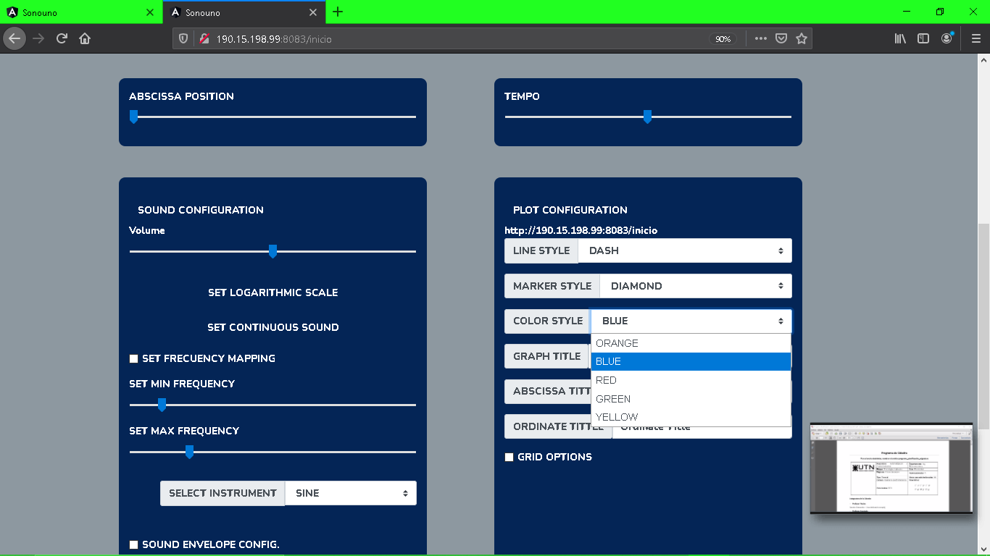

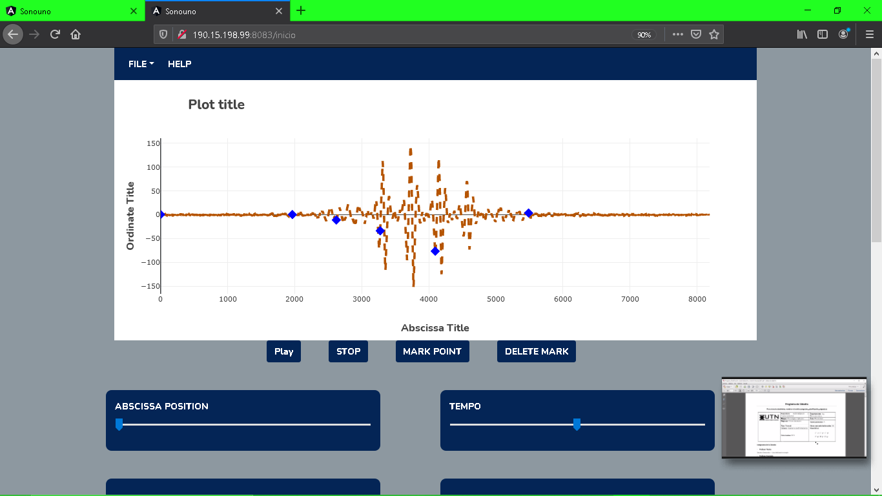

#### Image 42 The color style element is a drop-down list, where there are seven options. In the image the orange color style is selected. In addition, the dotted line style and circle marker have been chosen.

# 7.2.2 Modifying the titles.

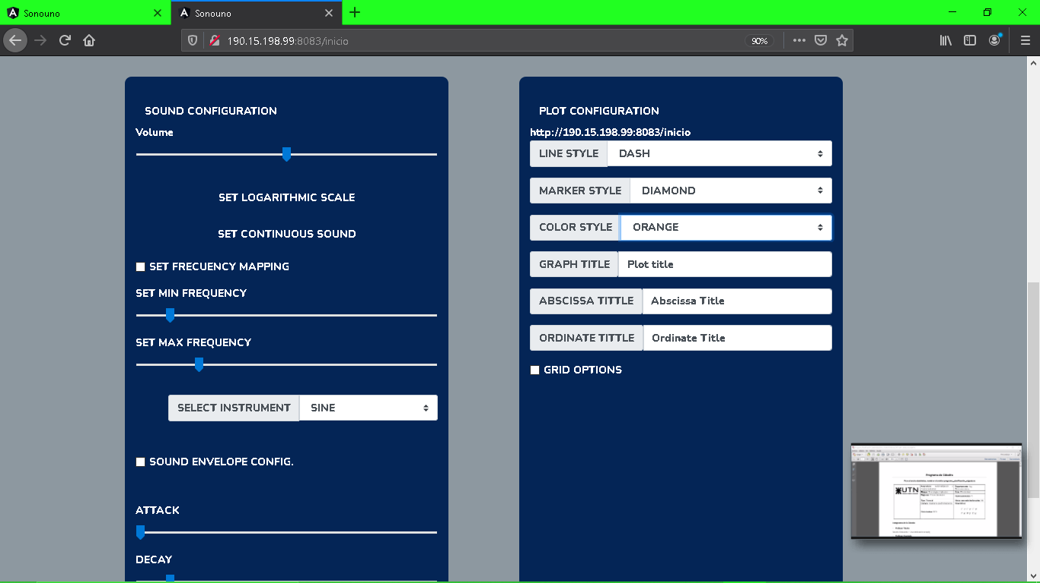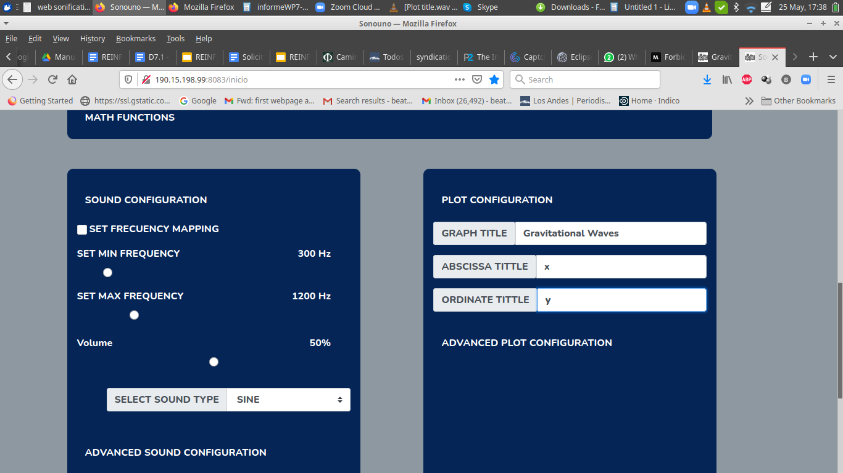

#### Image 43 Plot and axes names

To modify the title just edit the text inside the text box next to the label of the title you want to edit (Image 43). The changes apply immediately after every keystroke and there's no need to type “enter” after editing it (Image 44)

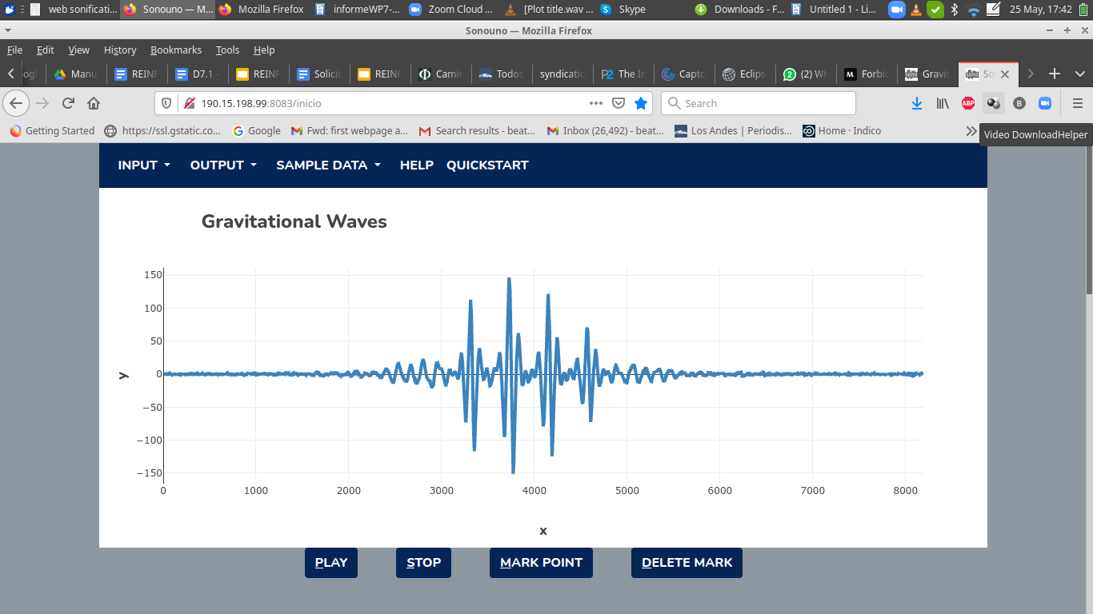

#### Image 44. New color and Plot and axes names

# 8. Mathematical Functions

The last version of sonoUno web includes the possibility to apply predefined mathematical functions, such as logarithm, square and smooth (Image 45), to the data. It is the first approach to the next step, which will allow you to use any function

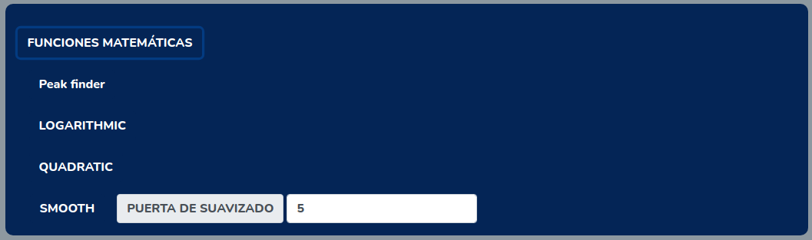

#### Image 45 .Predefined mathematical functions

# 8.1 Peak finder

This function allows you to mark the peaks in the graph. For the intents of this function a peak is defined by the value that is bigger than the previous and next values and that also checks with the condition of being above the average of the graph plus a value calculated by the spread between the highest and lowest value multiplied by the sensitivity percentage

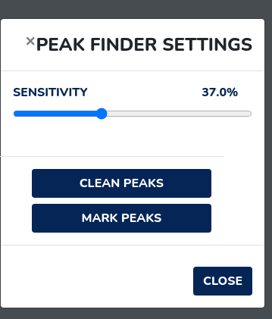

#### Image 46.Modal window with the peak finder settings

The settings window counts with a sensitivity slider that you can set to the value that best works for the current data. A button for cleaning the peaks and a button to add them like markers on the graph. Once you have marked them on the graph you can previsualize the effects of the changes on the slider.

For closing the modal window you can click the "Close" button on the bottom left, the X besides the title or you can press the Escape key on your keyboard

# 8.2 Logarithmic

This function allows you to apply the common logarithmic to every value on the data set and updates the graph accordingly.

# 8.3 Quadratic

This function allows you to update every value in the data set with its square and update the graph.

# 8.4 Smooth

This function allows you to use a moving average data smoothing with the gate value indicating the average of how many values are used. By this you mitigate the impacts of short fluctuations.

# 9. Shortcut keys-Comments